**Execution count profile of System.arrayCopy on SPECjbb2015:**

**SPROMPT>tail -10 Group1.Backend.JVM2.log_byte**

**Profiled Function : System.arraycopy**

**Block Size Bins :**

**0-32 : 21754494**

**33-64 : 1510584**

**65-128 : 756375**

**129-256 : 216357**

**257-512 : 172658**

**513-1024: 116310**

**> 1024 : 93699**

**Non-Const: 0**

**SPROMPT>tail -10 Group1.Backend.JVM2.log_short**

**Profiled Function : System.arraycopy**

**Block Size Bins :**

**0-32 : 93**

**33-64 : 15**

**65-128 : 126**

**129-256 : 674**

**257-512 : 22**

**513-1024: 5195**

**> 1024 : 1516**

**Non-Const: 0**

**SPROMPT>tail -10 Group1.Backend.JVM2.log_int**

**Profiled Function : System.arraycopy**

**Block Size Bins :**

**0-32 : 3621879**

**33-64 : 2128339**

**65-128 : 721420**

**129-256 : 576495**

**257-512 : 83195**

**513-1024: 45993**

**> 1024 : 46974**

**Non-Const: 0**

**SPROMPT>tail -10 Group1.Backend.JVM2.log_long**

**Profiled Function : System.arraycopy**

**Block Size Bins :**

**0-32 : 2012759**

**33-64 : 862110**

**65-128 : 3234**

**129-256 : 1060**

**257-512 : 131672**

**513-1024: 86990**

**> 1024 : 53376**

**Non-Const: 0**

**SPROMPT>tail -10 Group1.Backend.JVM2.log_all**

**Profiled Function : System.arraycopy**

**Block Size Bins :**

**0-32 : 32726276**

**33-64 : 4781881**

**65-128 : 1669544**

**129-256 : 834795**

**257-512 : 487804**

**513-1024: 323628**

**> 1024 : 226773**

**Optimized Stubs:**

**A: Current Algorithm without masked instruction:**

Case A) Block size less than 64 bytes:-

e.g. Instruction sequence for copying **24 bytes** from source to destination address.

__ movptr(byte_count, count);

__ shrptr(count, 3); // count => qword_count

__ lea(end_from, Address(from, qword_count, Address::times_8, -8));

__ lea(end_to, Address(to, qword_count, Address::times_8, -8));

__ negptr(qword_count); // make the count negative

__ jmp(L_copy_bytes); [ Static prediction hit: Unconditional jump target]

………

__ BIND(L_copy_bytes);

__ cmpptr(qword_count, (-1 * AVX3Threshold / 8));

__ jccb(Assembler::less, L_above_threshold);

__ jmpb(L_below_threshold); [ Static prediction miss: forward conditional jump]

………

__ BIND(L_below_threshold);

__ addptr(qword_count, 8);

__ jcc(Assembler::lessEqual, L_loop_avx2); [ Wrong Static prediction: backward conditional jump target taken]

__ bind(L_32_byte_head);

__ subptr(qword_count, 4); // sub(8) and add(4)

__ jccb(Assembler::greater, L_end); [ Static predictopn

………

__ BIND(L_end);

if (UseAVX >= 2) {

// clean upper bits of YMM registers

__ vpxor(xmm0, xmm0);

__ vpxor(xmm1, xmm1);

}

__ subptr(qword_count, 4);

__ jcc(Assembler::less, L_copy_8_bytes); // Copy trailing qwords [ Correct static prediction, backward conditional branch]

………

// Copy trailing qwords

__ BIND(L_copy_8_bytes);

__ movq(rax, Address(end_from, qword_count, Address::times_8, 8));

__ movq(Address(end_to, qword_count, Address::times_8, 8), rax);

__ increment(qword_count);

__ jcc(Assembler::notZero, L_copy_8_bytes);

__ BIND(L_copy_4_bytes); [ Extra conditional check ]

__ testl(byte_count, 4);

__ jccb(Assembler::zero, L_copy_2_bytes);

__ BIND(L_copy_2_bytes); [ Extra conditional check ]

__ testl(byte_count, 2);

__ jccb(Assembler::zero, L_copy_byte);

__ BIND(L_copy_byte);

__ testl(byte_count, 1);

__ jccb(Assembler::zero, L_exit);

__ BIND(L_exit);

address ucme_exit_pc = __ pc();

restore_arg_regs();

inc_counter_np(SharedRuntime::_jbyte_array_copy_ctr); // Update counter after rscratch1 is free

__ xorptr(rax, rax); // return 0

__ vzeroupper();

__ leave(); // required for proper stackwalking of RuntimeStub frame

__ ret(0);

New instruction sequence using AVX512 masked copy instruction:

// Zero length check.

__ cmpq(count, 0);

__ jcc(Assembler::lessEqual, L_exit); [ Length <= 0 ]

// temp3 = -1

__ xorq(temp3, temp3);

__ decq(temp3);

__ cmpq(count, 64);

__ jcc(Assembler::greater, L_entry); [ Favoring static branch misprediction ]

// Special case for length less than 64 bytes

// TODO: Unswitch it to compile side.

__ negptr(count);

__ addq(count, 64);

__ shrxq(temp3, temp3, count);

__ kmovql(k2, temp3);

__ evmovdqub(xmm1, k2, Address(from, 0), Assembler::AVX_512bit);

__ evmovdqub(Address(to, 0), k2, xmm1, Assembler::AVX_512bit);

__ jmpb(L_exit);

__ xorptr(rax, rax); // return 0

__ vzeroupper();

__ leave(); // required for proper stack walking of Runtime Stub frame

__ ret(0);

**Case B > Block size greater than 64 bytes (unaligned) e.g. Instruction sequence for copying blocks having sizes in multiple of 64 bytes from source to destination address.**

**Current Algorithm:**

__ movptr(byte_count, count);

__ shrptr(count, 3); // count => qword_count

__ lea(end_from, Address(from, qword_count, Address::times_8, -8));

__ lea(end_to, Address(to, qword_count, Address::times_8, -8));

__ negptr(qword_count); // make the count negative

**__ jmp(L_copy_bytes);**  [ Static prediction hit: Unconditional jump target]

………

__ BIND(L_copy_bytes);

__ cmpptr(qword_count, (-1 * AVX3Threshold / 8));

**__ jccb(Assembler::less, L_above_threshold);**

__ bind(L_loop_avx512);

__ evmovdqul(xmm0, Address(end_from, qword_count, Address::times_8, -56), Assembler::AVX_512bit);

__ evmovdqul(Address(end_to, qword_count, Address::times_8, -56), xmm0, Assembler::AVX_512bit);

__ bind(L_above_threshold);

__ addptr(qword_count, 8);

**__ jcc(Assembler::lessEqual, L_loop_avx512);**

**__ jmpb(L_32_byte_head);**

__ bind(L_32_byte_head);

__ subptr(qword_count, 4); // sub(8) and add(4)

**__ jccb(Assembler::greater, L_end);**

__ BIND(L_end);

if (UseAVX >= 2) {

// clean upper bits of YMM registers

__ vpxor(xmm0, xmm0);

__ vpxor(xmm1, xmm1);

}

__ subptr(qword_count, 4);

**__ jcc(Assembler::less, L_copy_8_bytes); // Copy trailing qwords**

………

// Copy trailing qwords

__ BIND(L_copy_8_bytes);

__ movq(rax, Address(end_from, qword_count, Address::times_8, 8));

__ movq(Address(end_to, qword_count, Address::times_8, 8), rax);

__ increment(qword_count);

**__ jcc(Assembler::notZero, L_copy_8_bytes);**

__ BIND(L_copy_4_bytes);

__ testl(byte_count, 4);

**__ jccb(Assembler::zero, L_copy_2_bytes);**

__ BIND(L_copy_2_bytes);

__ testl(byte_count, 2);

**__ jccb(Assembler::zero, L_copy_byte);**

__ BIND(L_copy_byte);

__ testl(byte_count, 1);

**__ jccb(Assembler::zero, L_exit);**

__ BIND(L_exit);

__ xorptr(rax, rax); // return 0

__ vzeroupper();

__ leave(); // required for proper stackwalking of RuntimeStub frame

__ ret(0);

New Algorithm:

// Zero length check.

__ cmpq(count, 0);

**__ jcc(Assembler::lessEqual, L_exit);**

// temp3 = -1

__ xorq(temp3, temp3);

__ decq(temp3);

__ cmpq(count, 64);

**__ jcc(Assembler::greater, L_entry); [ Static prediction miss: forward jump non-contiguous basic block]**

**…………**

// Regular pre-main-post loop.

// Alignment block.

__ BIND(L_entry);

__ movptr(temp1, to);

__ andq(temp1, 63);

__ movq(temp4, temp1);

__ negptr(temp4);

__ addq(temp4, 64);

__ movq(temp2, temp3);

__ shrxq(temp2, temp2, temp1);

__ kmovql(k2, temp2);

__ evmovdqub(xmm1, k2, Address(from, 0), Assembler::AVX_512bit);

__ evmovdqub(Address(to, 0), k2, xmm1, Assembler::AVX_512bit);

__ addptr(to, temp4);

__ addptr(from, temp4);

__ subq(count, temp4);

__ cmpq(count, 64);

**__ jcc(Assembler::lessEqual, L_tail);**

// Main loop with aligned copy block size of 64 bytes

__ BIND(L_main_loop);

__ evmovdqub(xmm1, Address(from, 0), Assembler::AVX_512bit);

__ evmovdqub(Address(to, 0), xmm1, Assembler::AVX_512bit);

__ addptr(to, 64);

__ addptr(from, 64);

__ subq(count, 64);

__ cmpq(count, 64);

**__ jcc(Assembler::greater, L_main_loop);**

// Tail loop.

__ BIND(L_tail);

__ negptr(count);

__ addptr(count, 64);

__ shrxq(temp3, temp3, count);

__ kmovql(k2, temp3);

__ evmovdqub(xmm1, k2, Address(from, 0), Assembler::AVX_512bit);

__ evmovdqub(Address(to, 0), k2, xmm1, Assembler::AVX_512bit);

__ BIND(L_exit);

}

__ xorptr(rax, rax); // return 0

__ vzeroupper();

__ leave(); // required for proper stackwalking of RuntimeStub frame

__ ret(0);

Case C > Greater than 64 bytes copy (aligned) : Sequence is same as above, but will not have any penalty of split loads and stored across cache line.

**OLD RESULTS:**

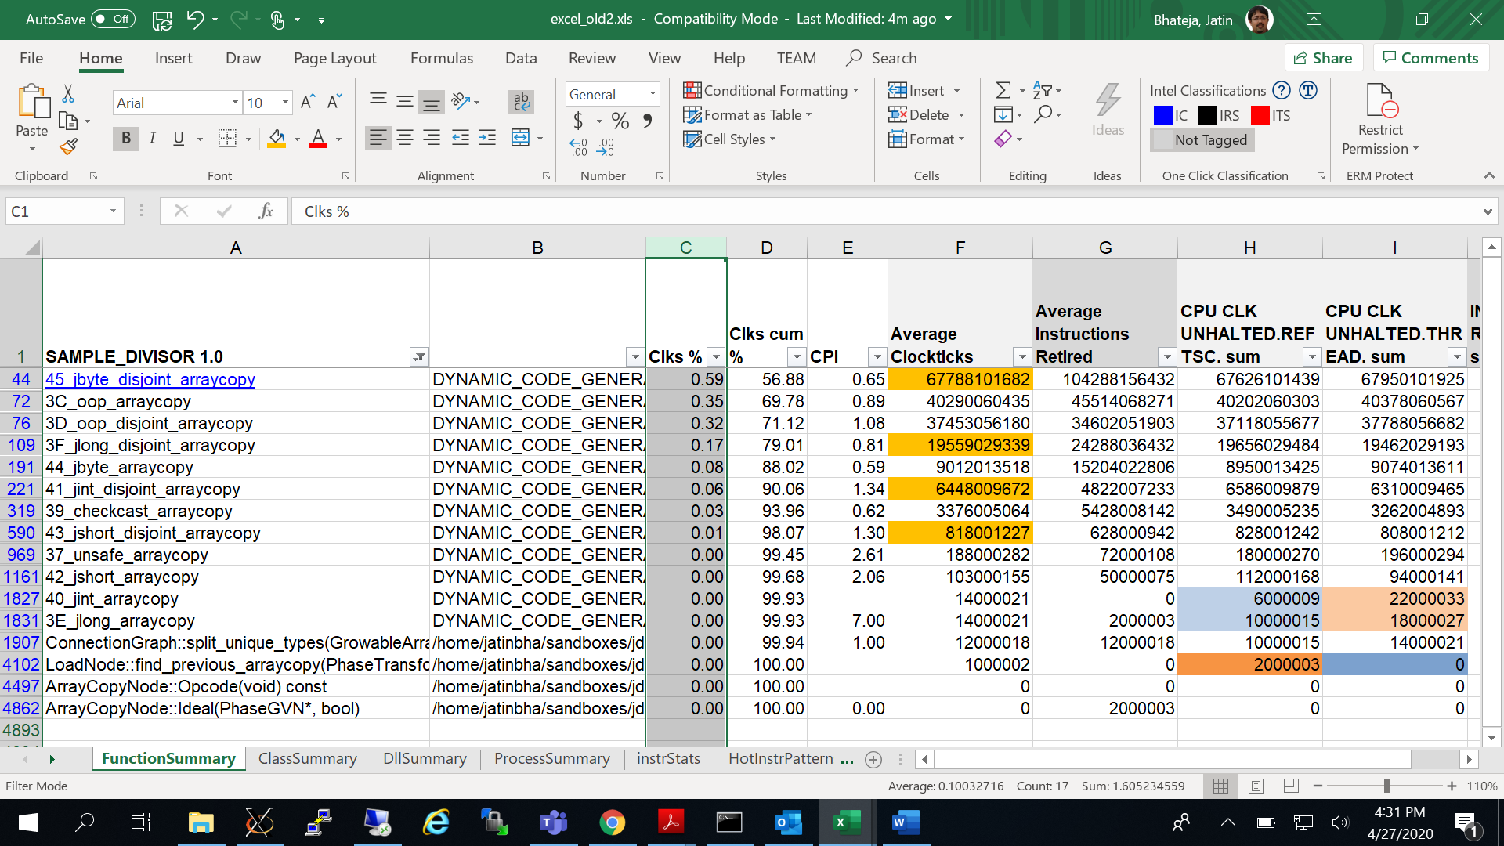

**NEW RESULTS:**

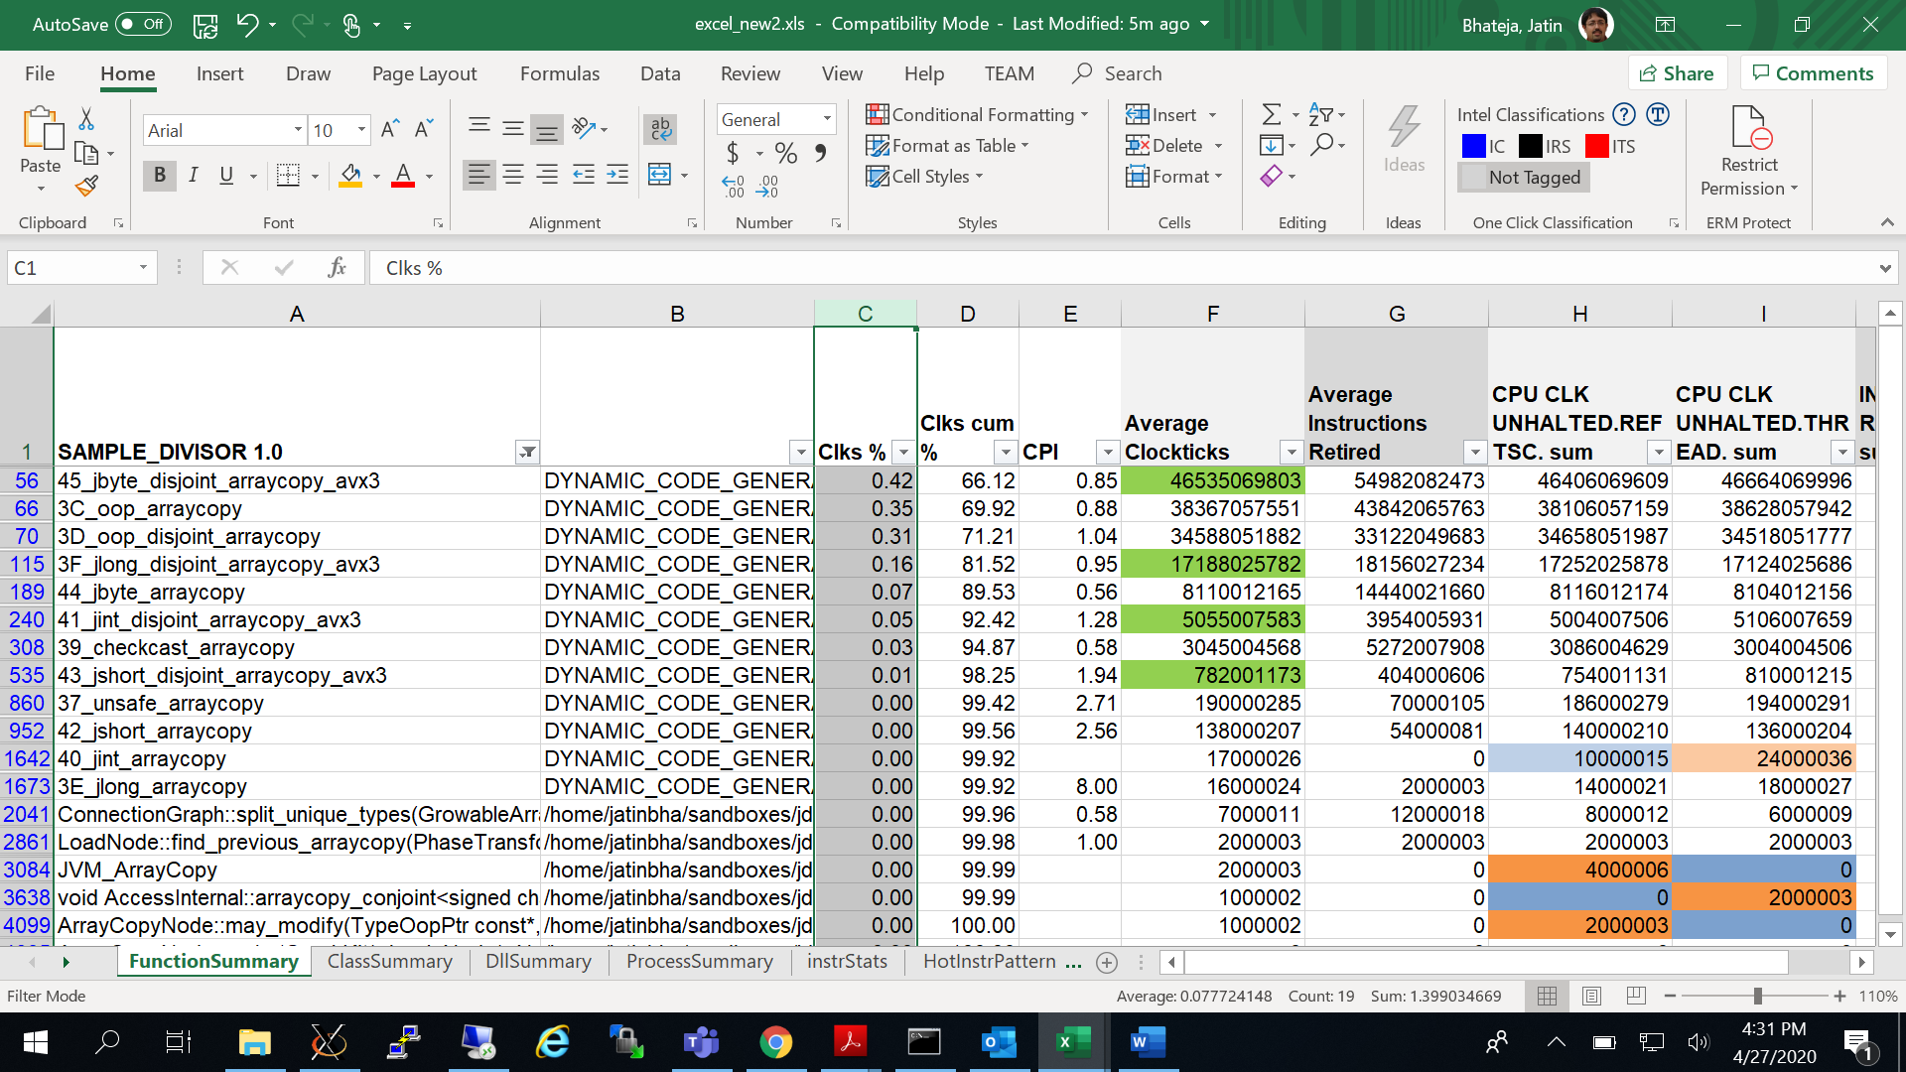

**Un-switching optimization:**

Core Basic Block:

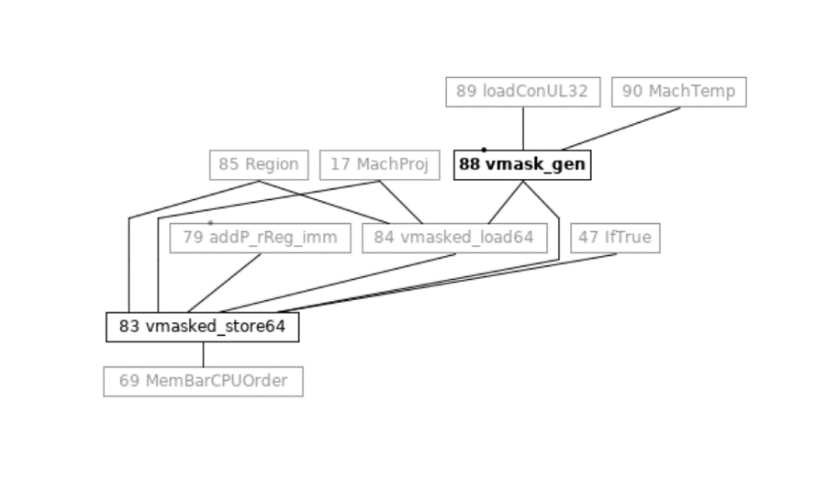

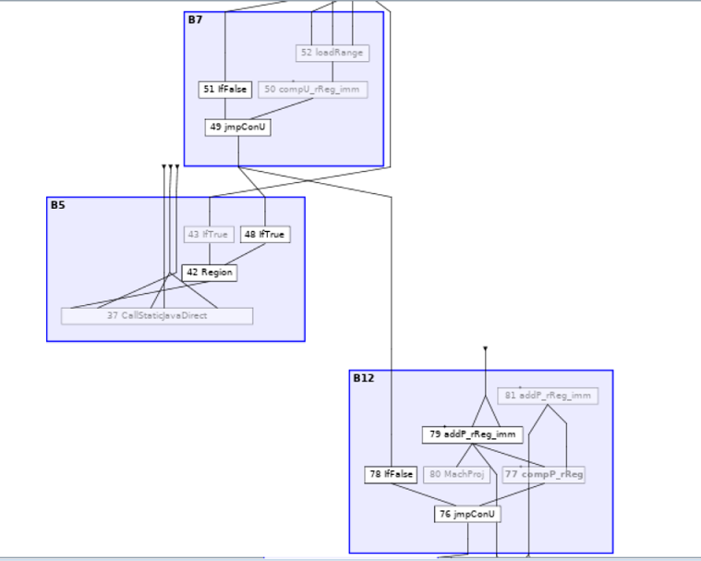

B5 = Uncommon trap

B12 = Predicate condition 1 for unswitching block.

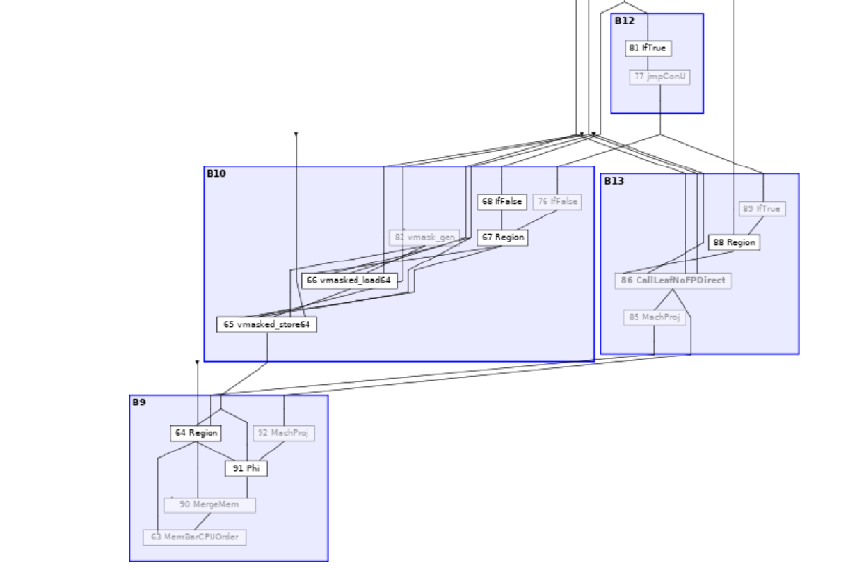

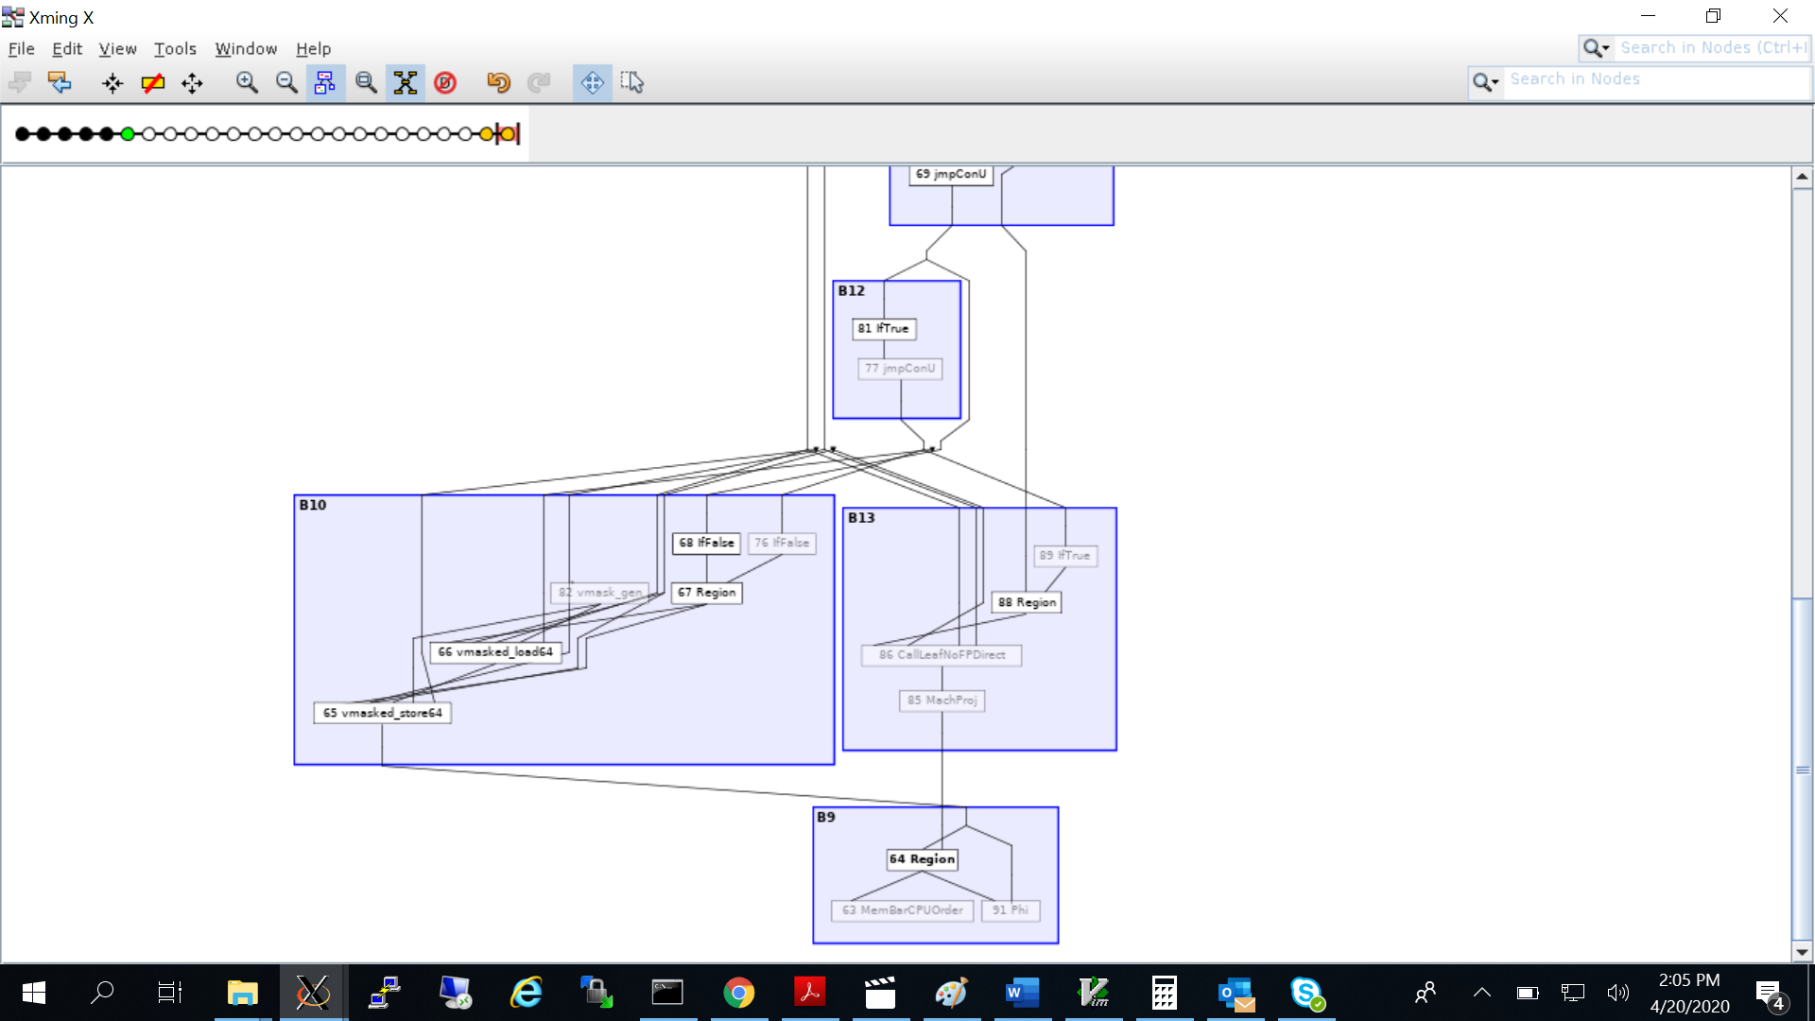

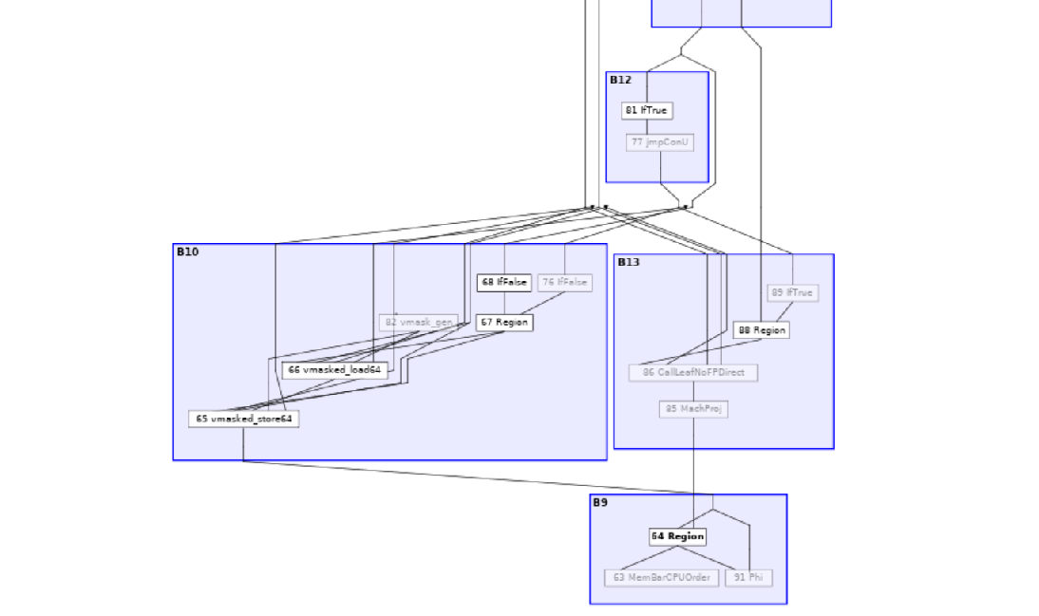

**Effect on register sizes on frequency drop and performance during masked copy.**

10 bytes masked copy using XMM VS ZMM registers.

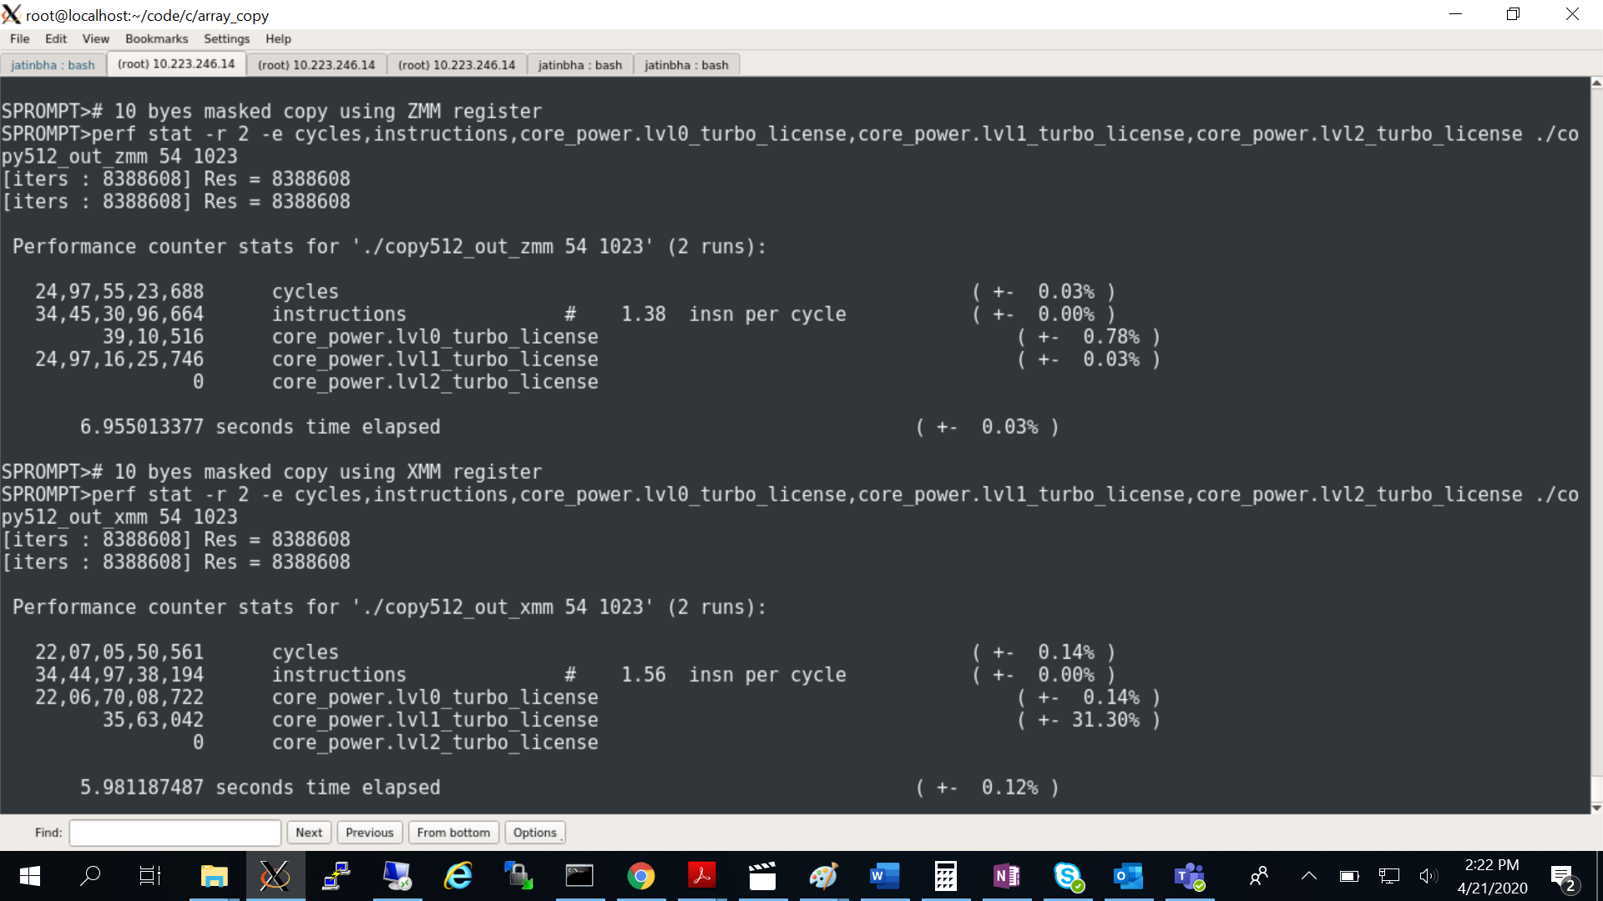

**Atomic copy using ZMM vs split copy using YMM/XMM registers.**

42 byte masked copy using ZMM register VS Split-copy using YMM register ( YMM + YMM_MASKED)

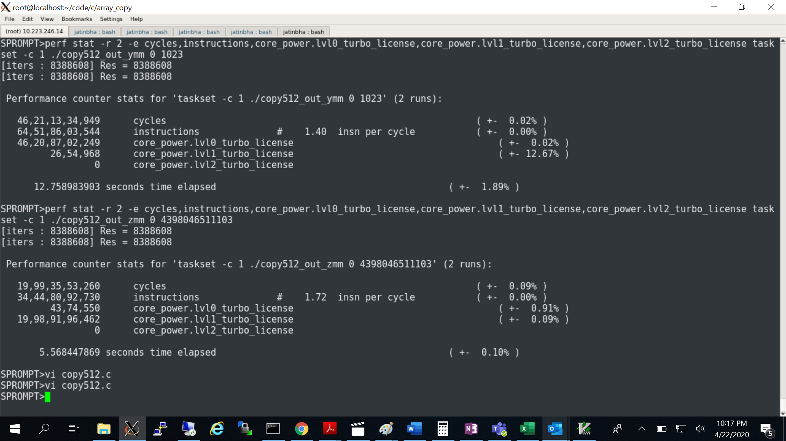

**Mask granularity effect:**

Mask operating at granularity of 64/32 bit offers better performance compared to 8bit for same copy sizes.

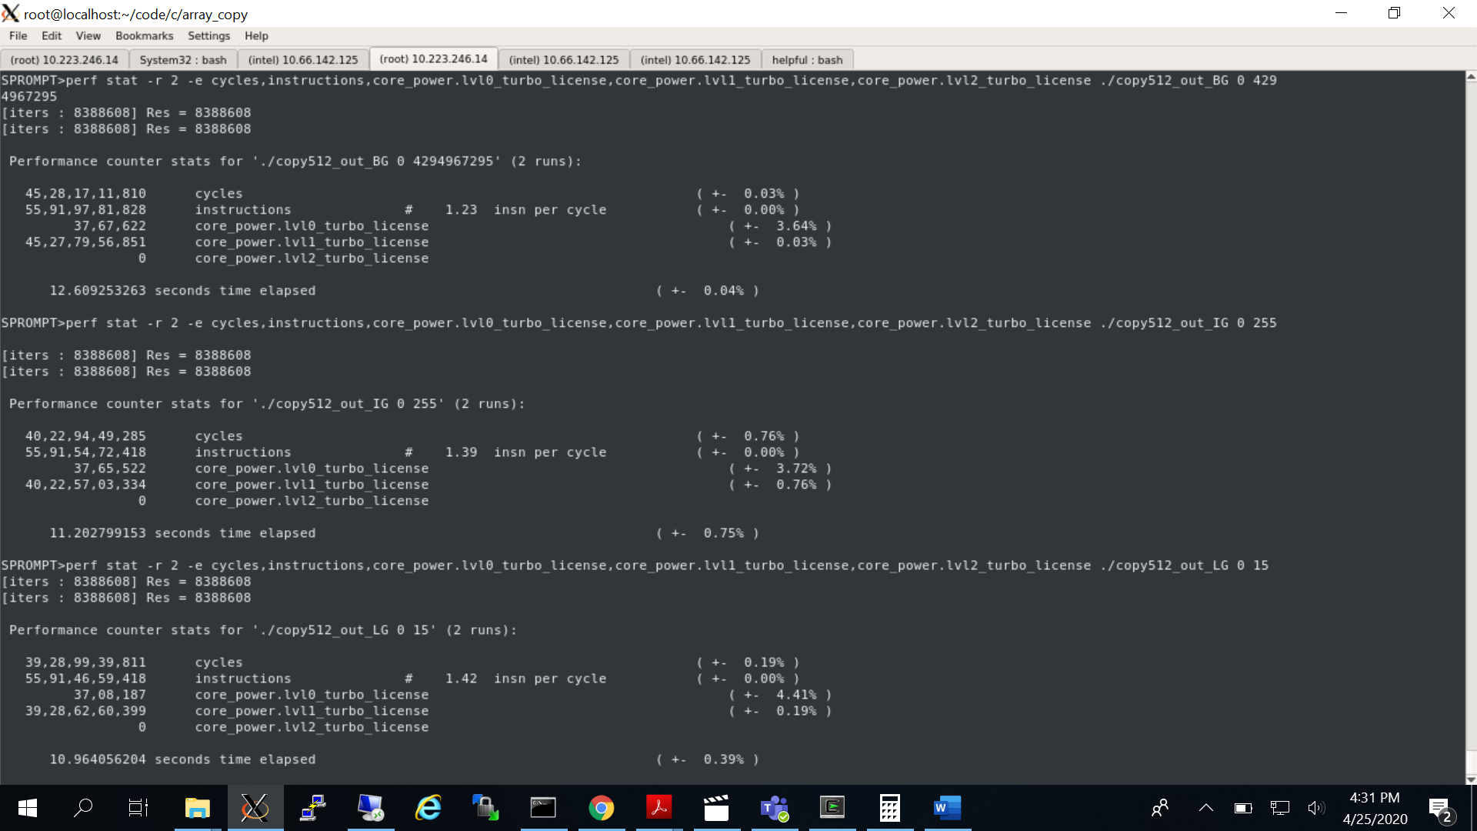

**Debug**:

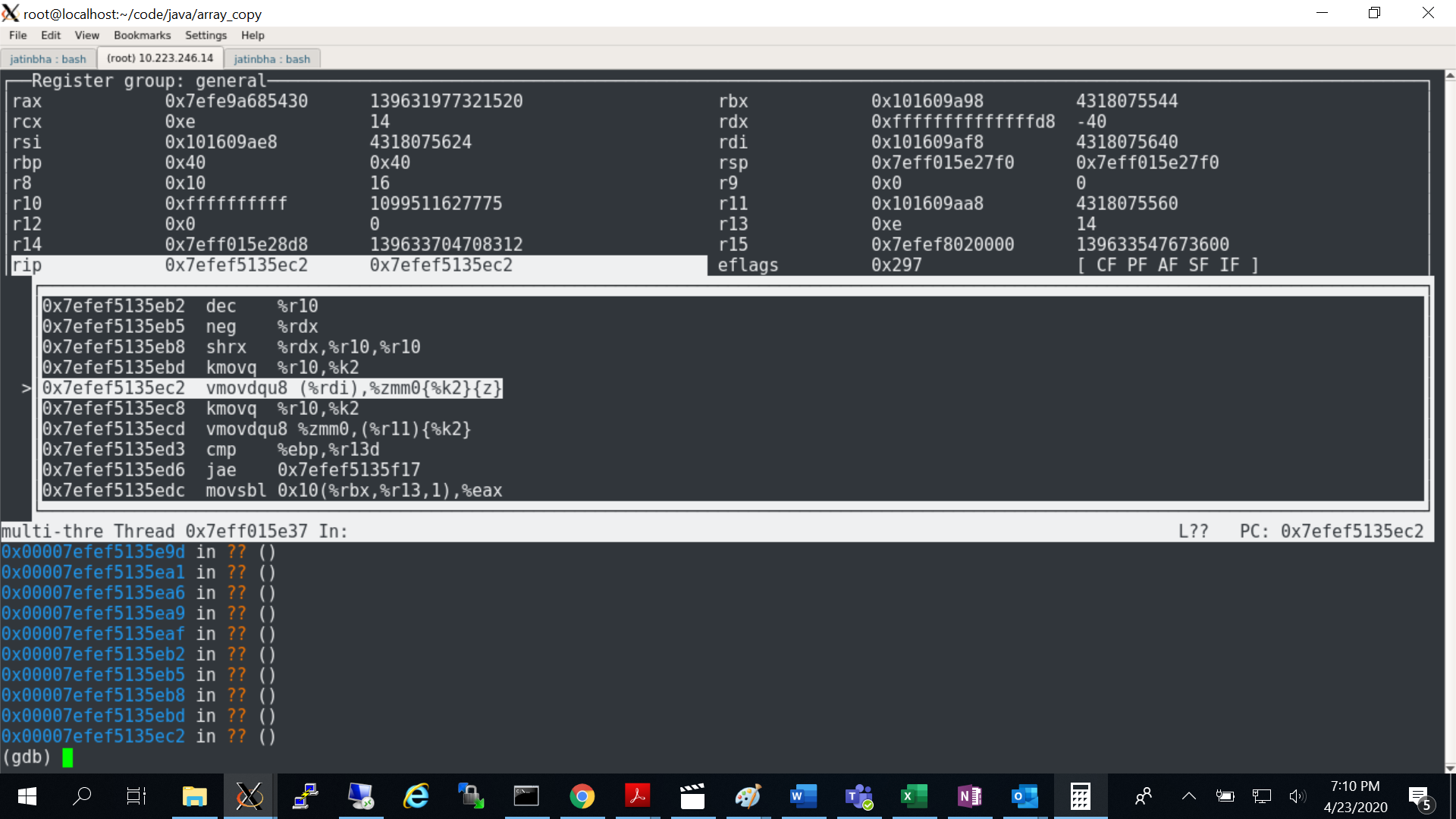

SKX - Synthetic test case

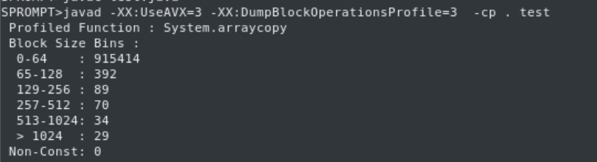

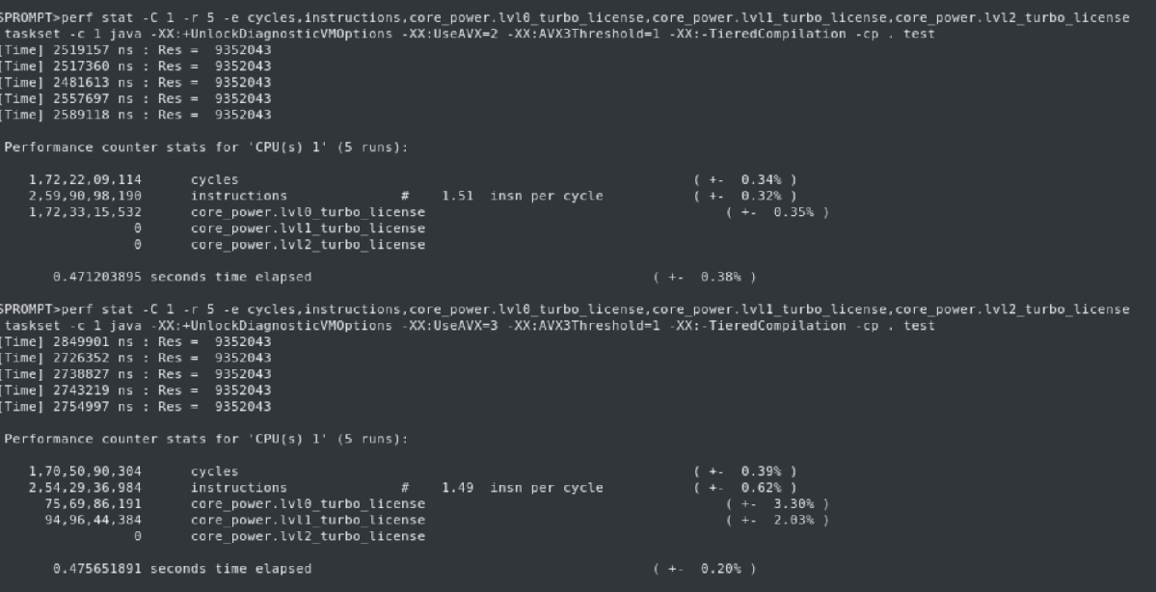

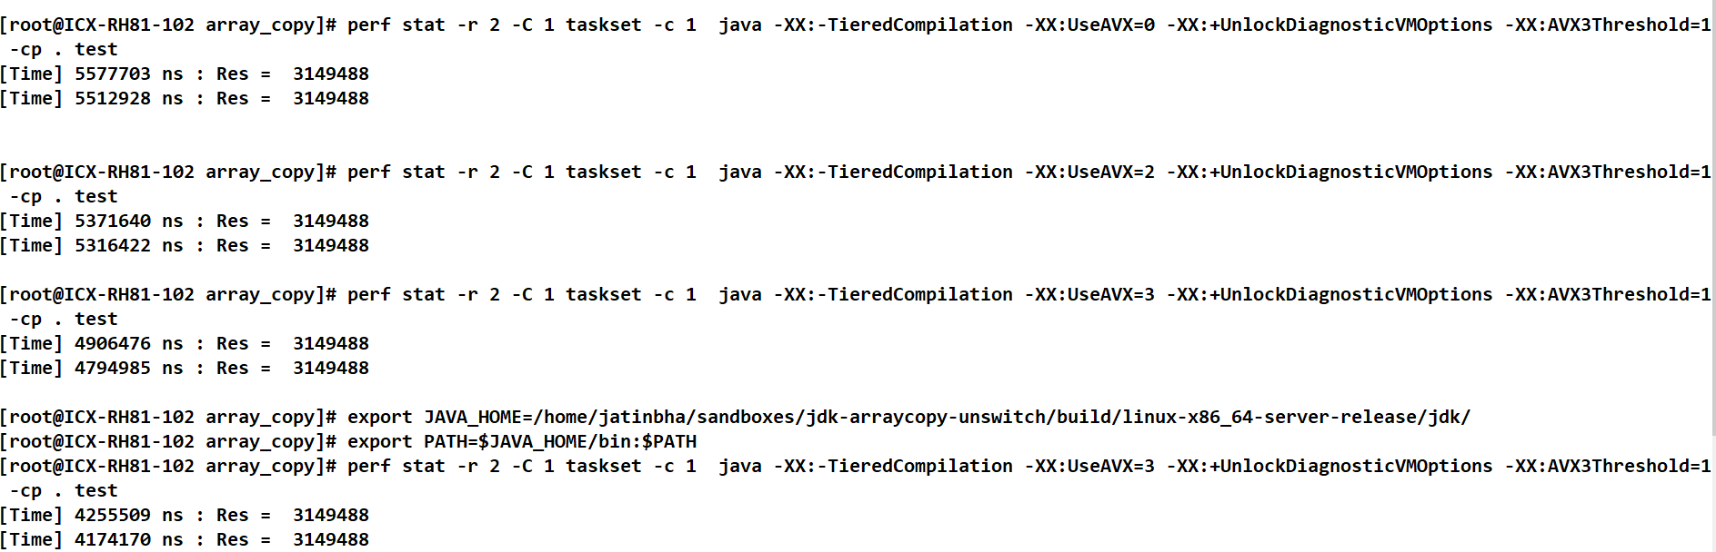

SPECjbb2015 – Profiles 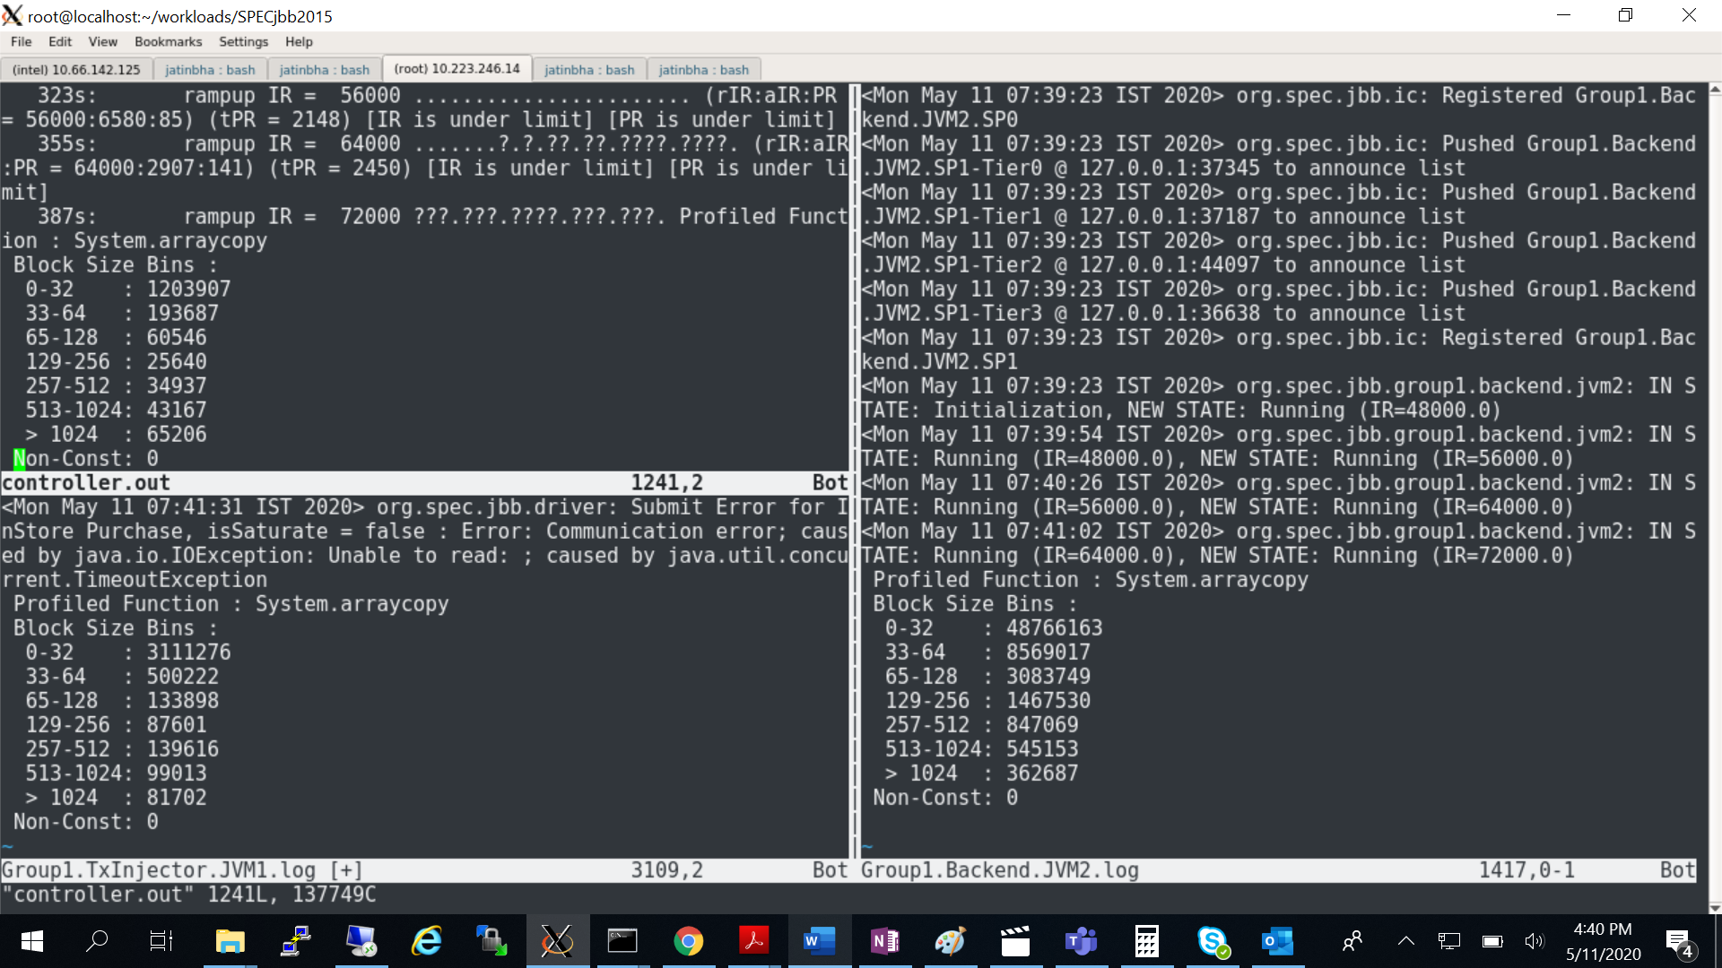

BYTE_ARRAY_COPY: NEW

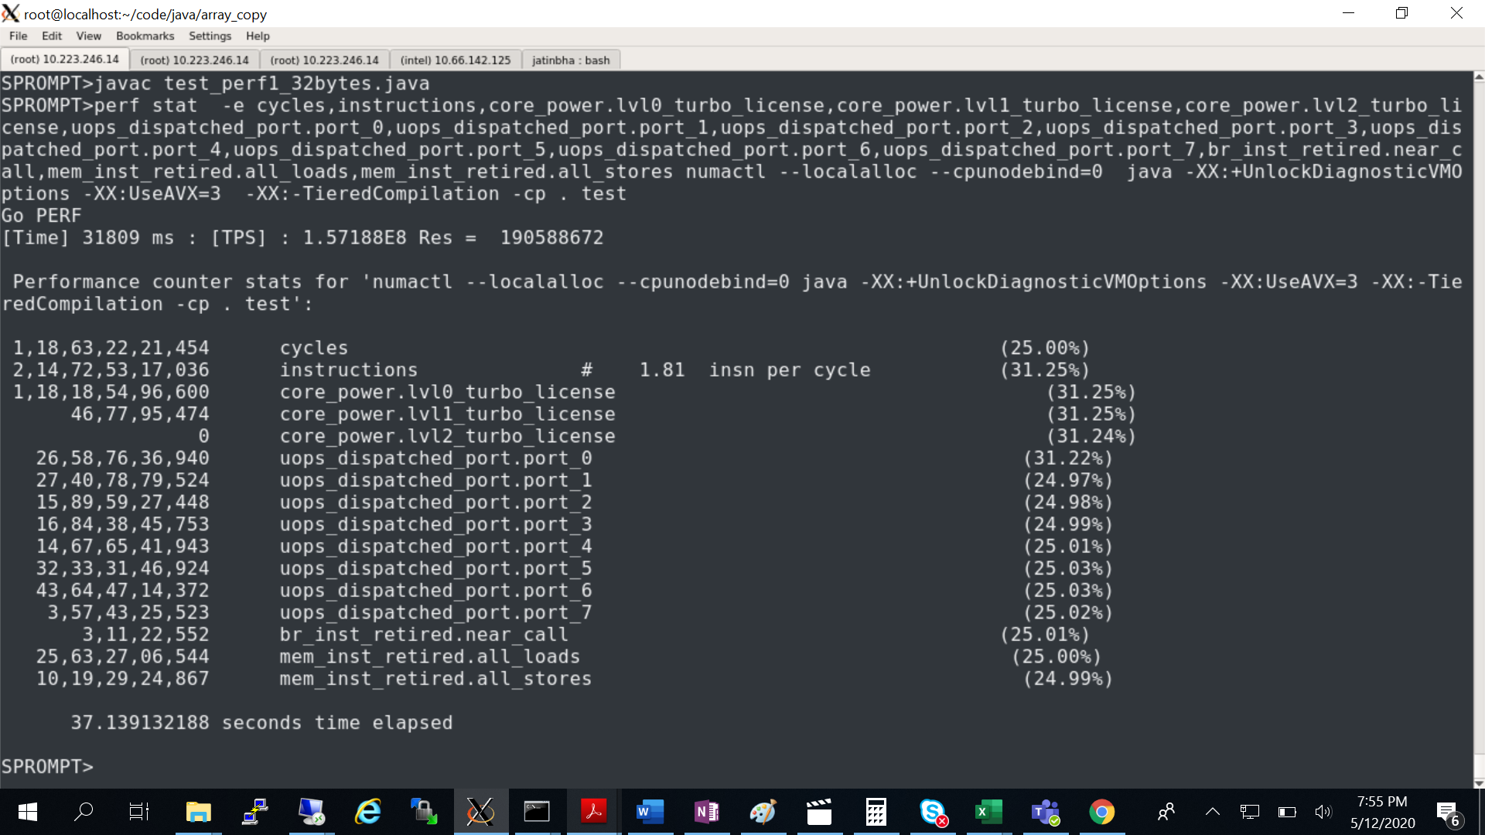

OLD:

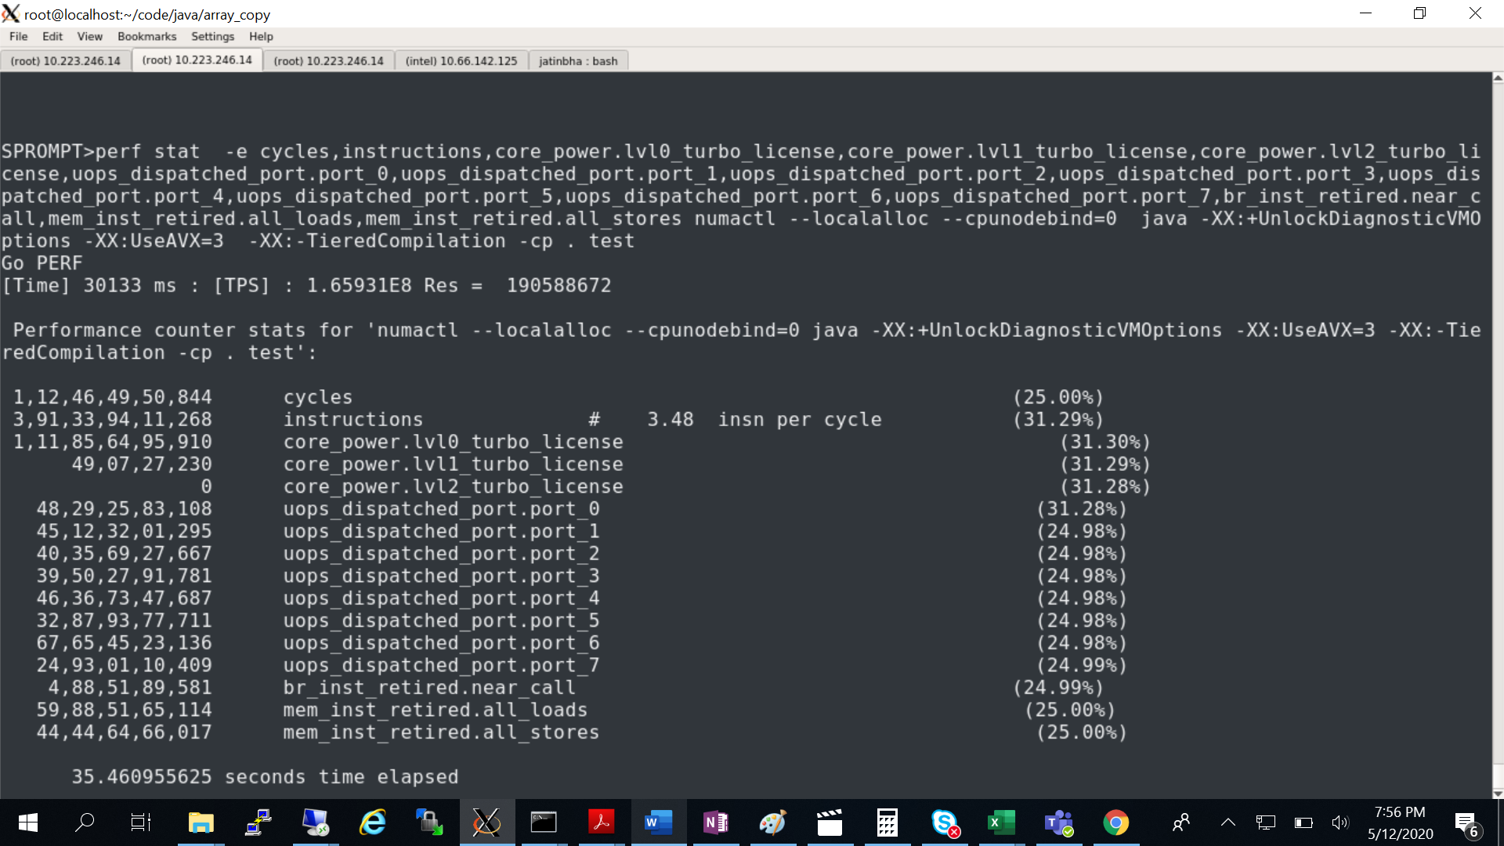

INT_ARRAY_COPY: NEW

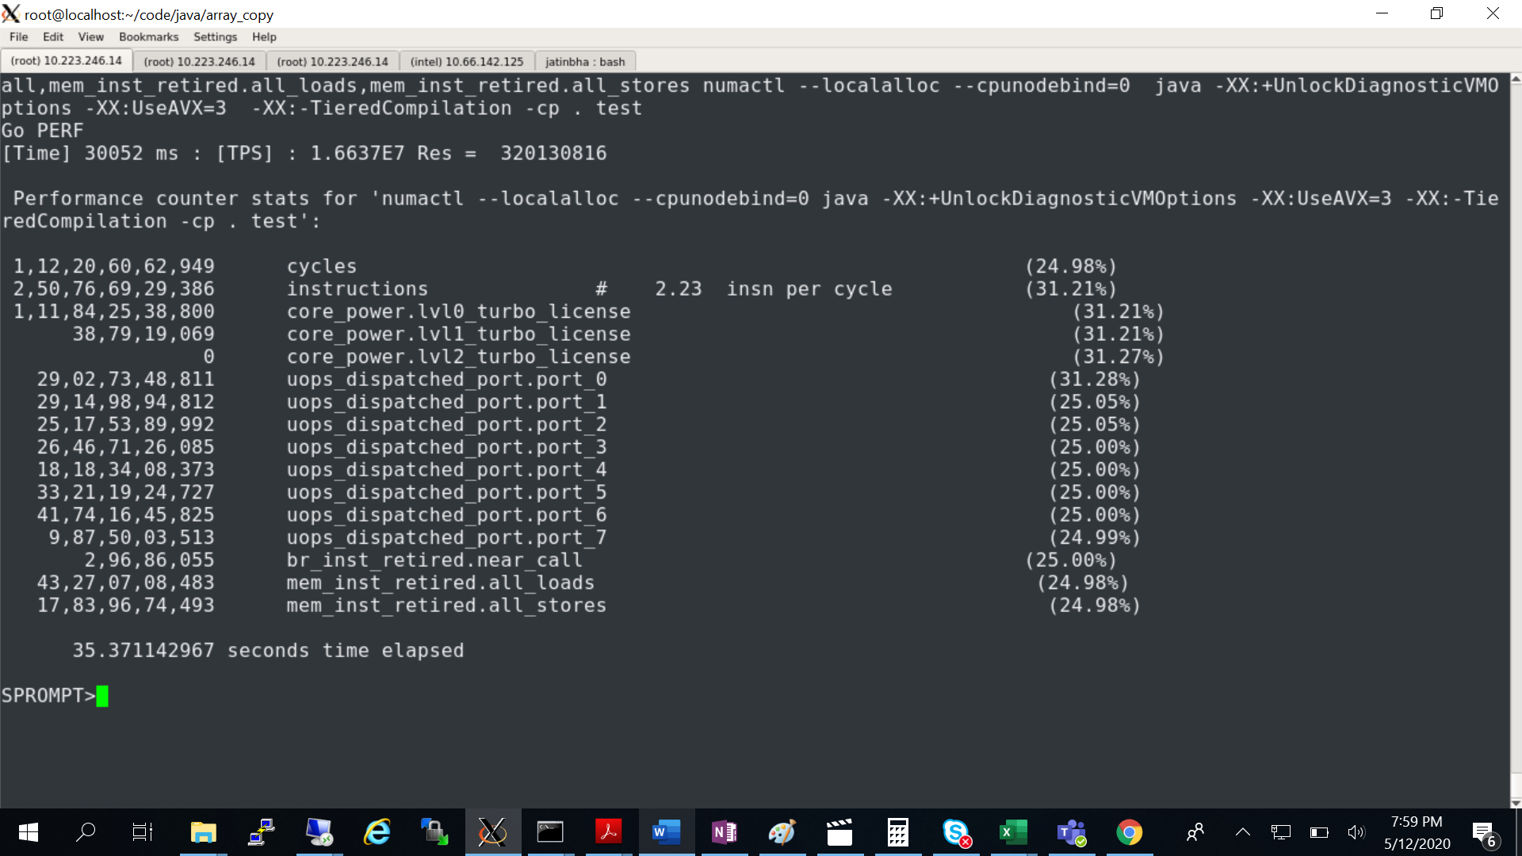

OLD:

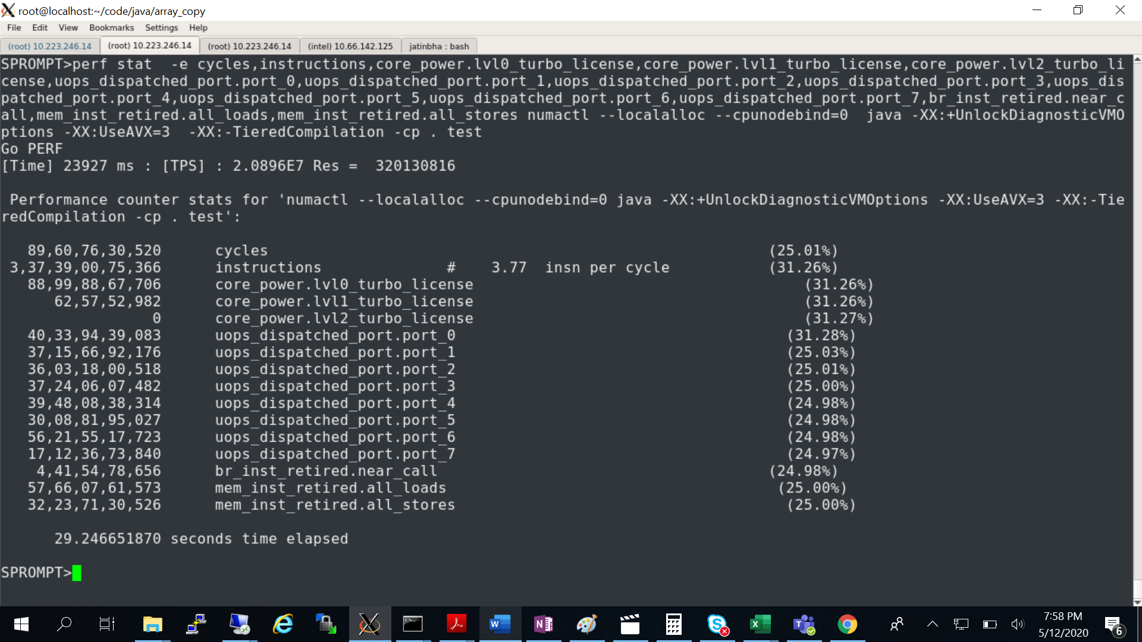

Perf data for BYTE_ARRAY: OLD ( stub tail (2 byte movw +1 byte movb) getting executed.

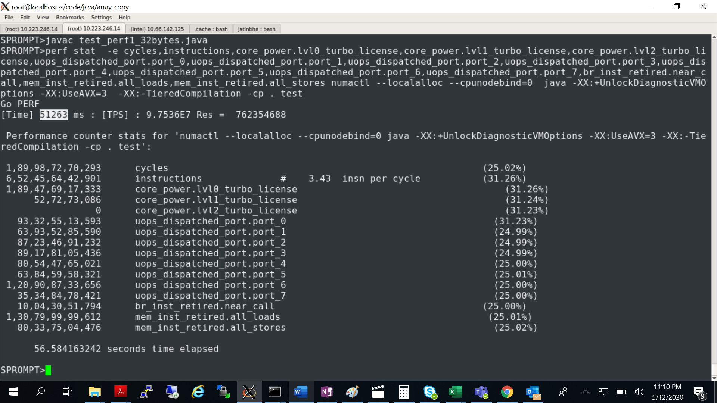

NEW:

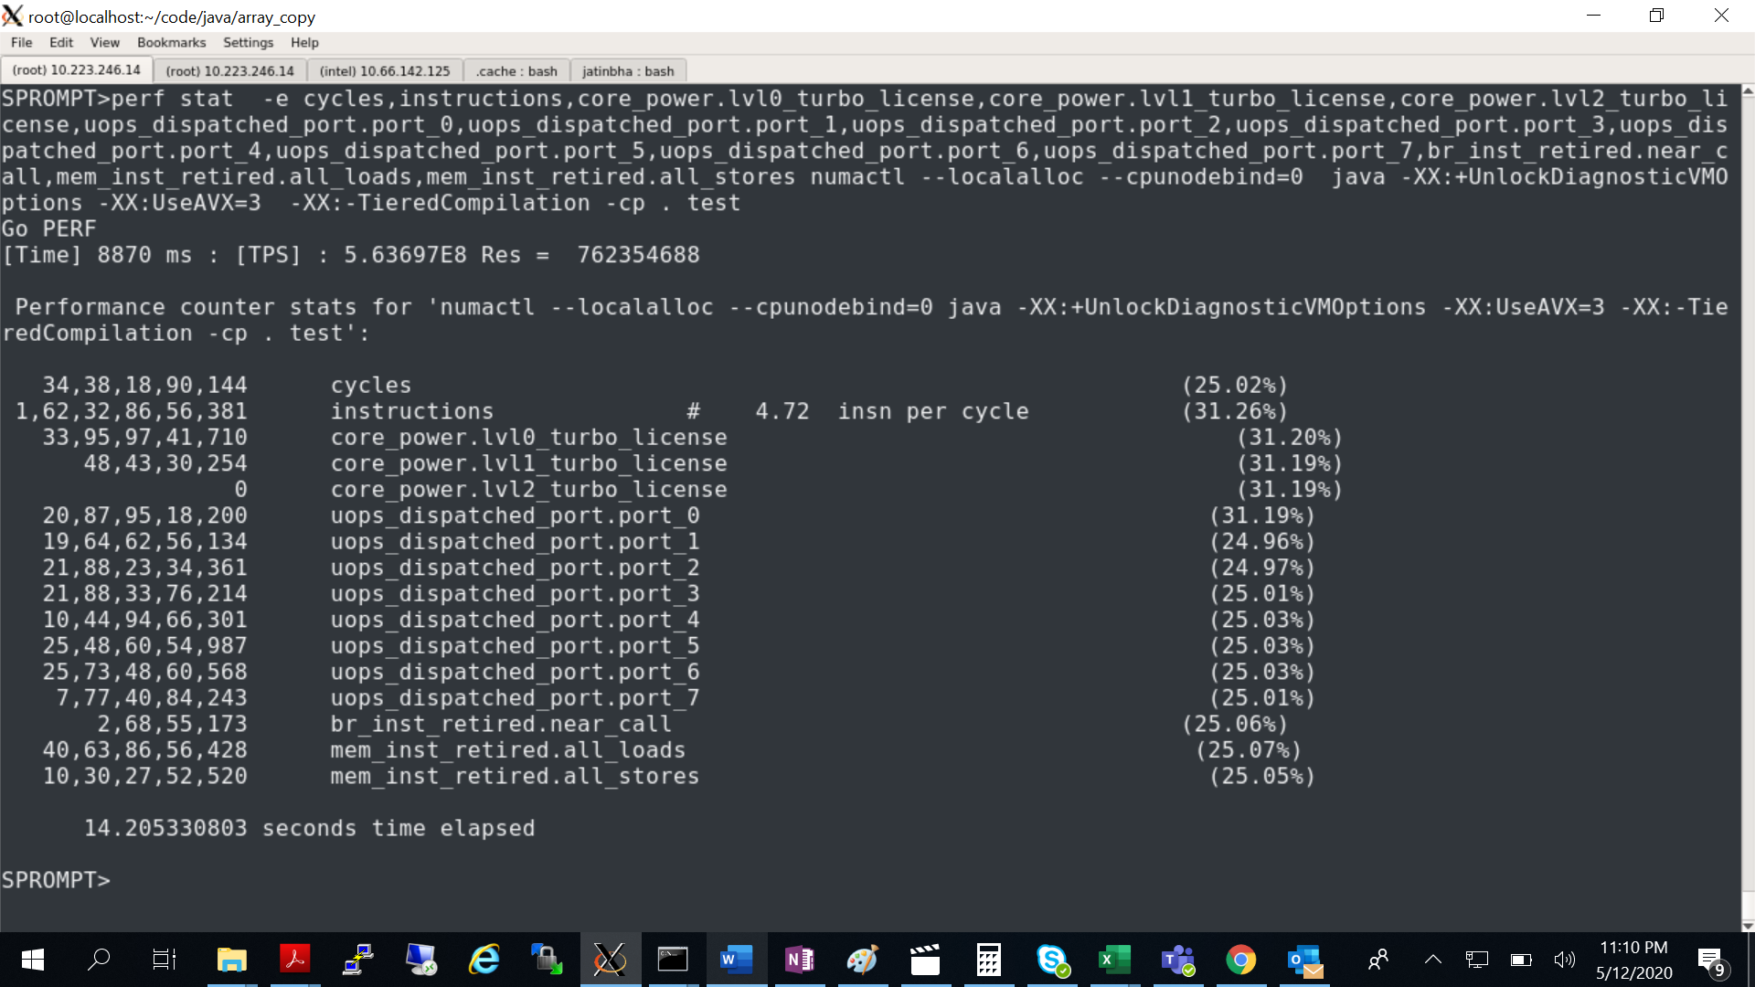

Bottom up profile (flat profile) showing similar block level cycles for both cases. Saving on extra call.

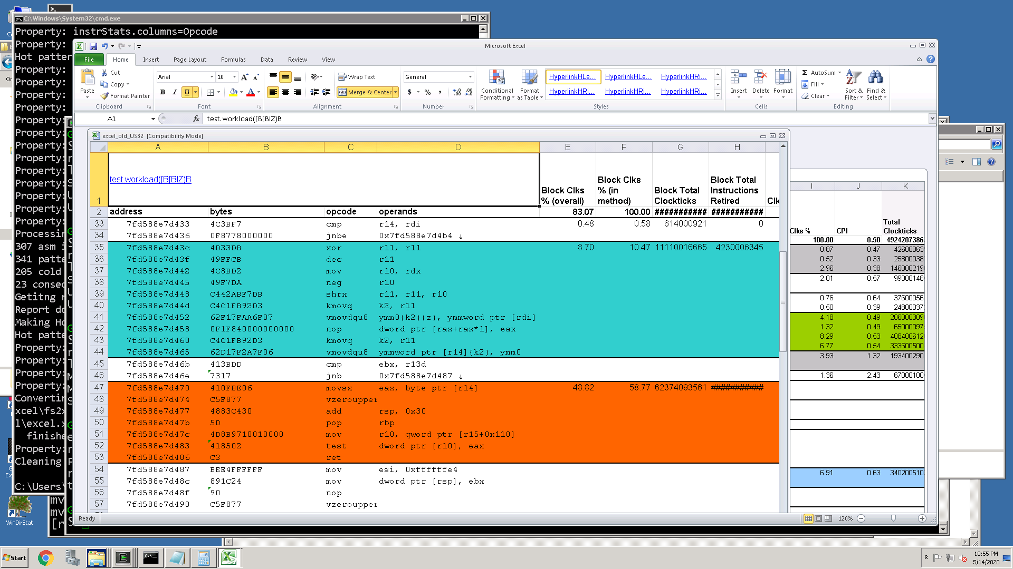

Total computation : stub calling block cycles + cycles spent in call (not visible in flat profile)

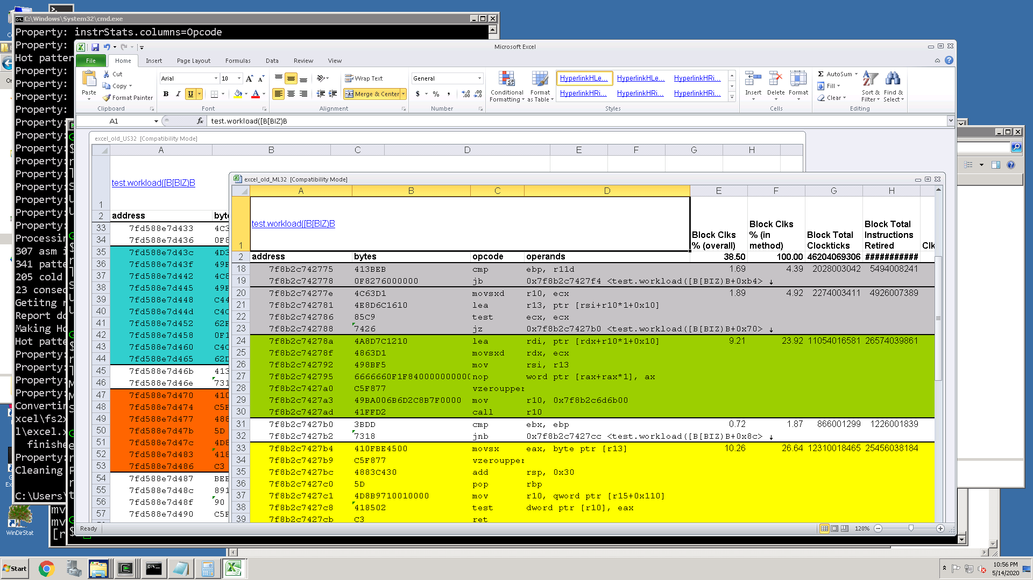

**VTUNE profiles:**

UNSWITCH : workload() {

System.arraycopy(src, cnt, dst, cnt, cnt)

Return dst[cnt];

}

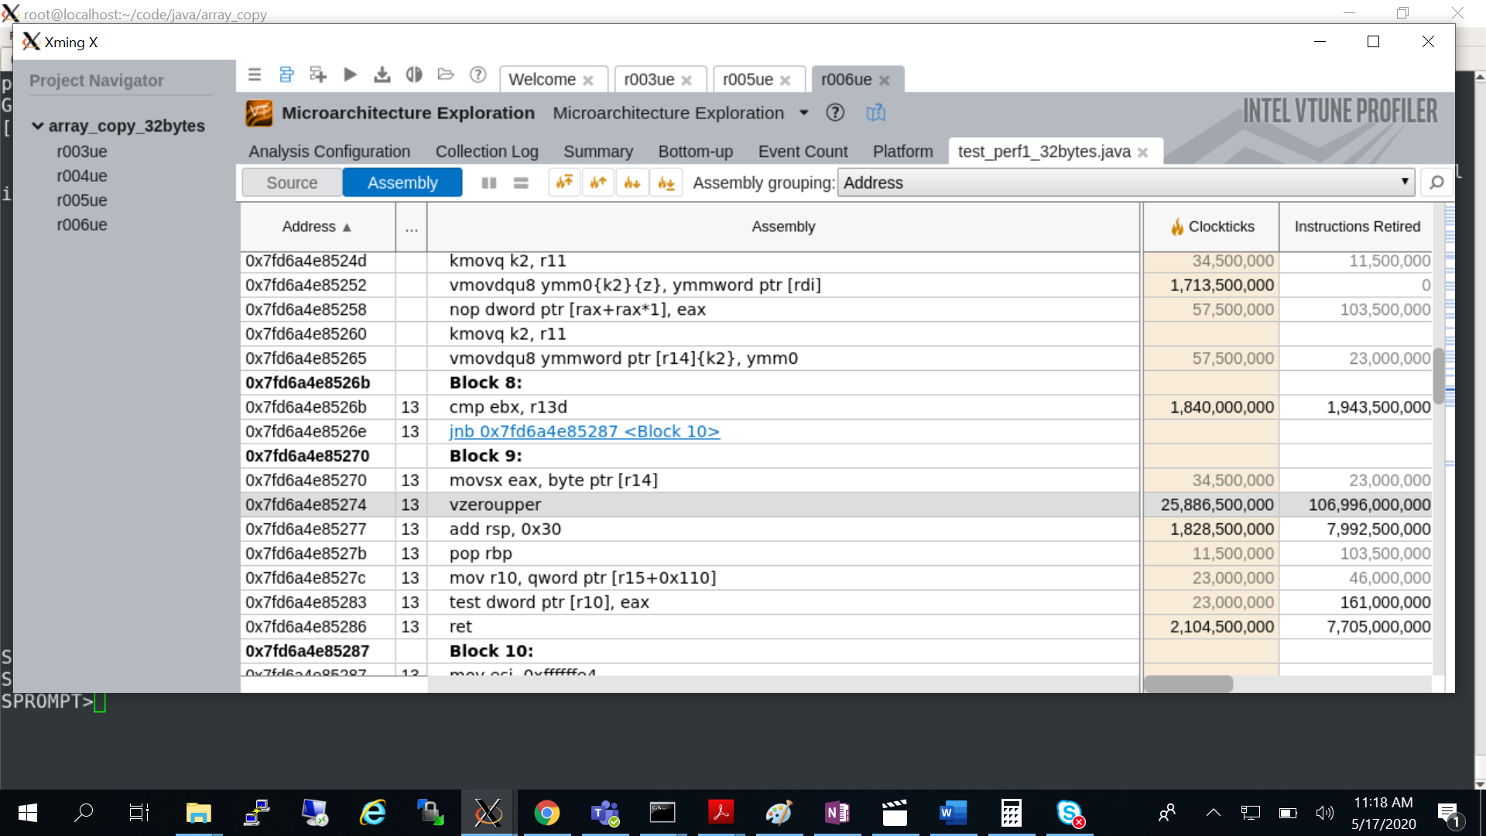

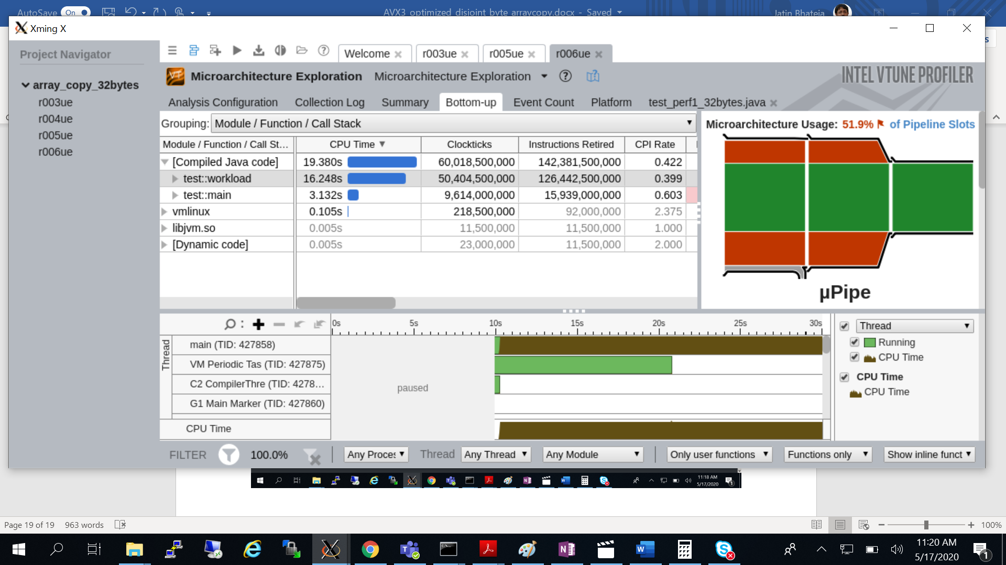

UNSWITCH: workload() {

System.arraycopy(src, cnt, dst, cnt, cnt)

Return dst[0];

}

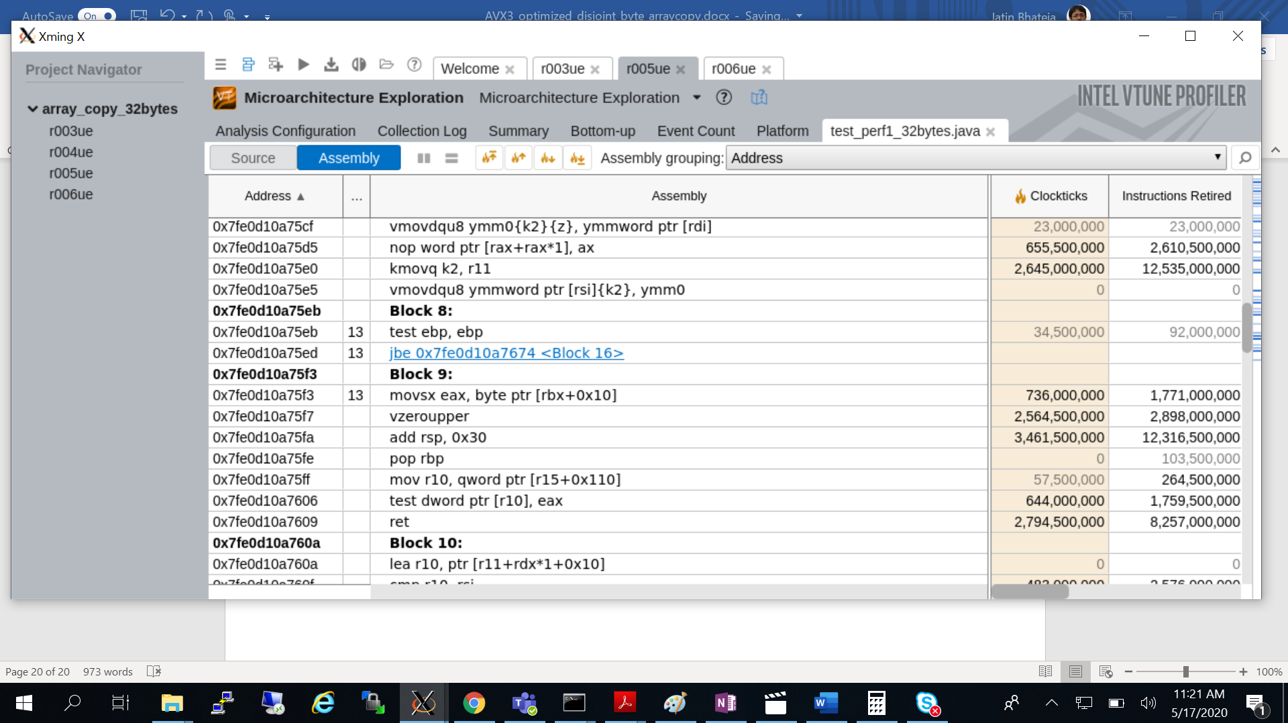

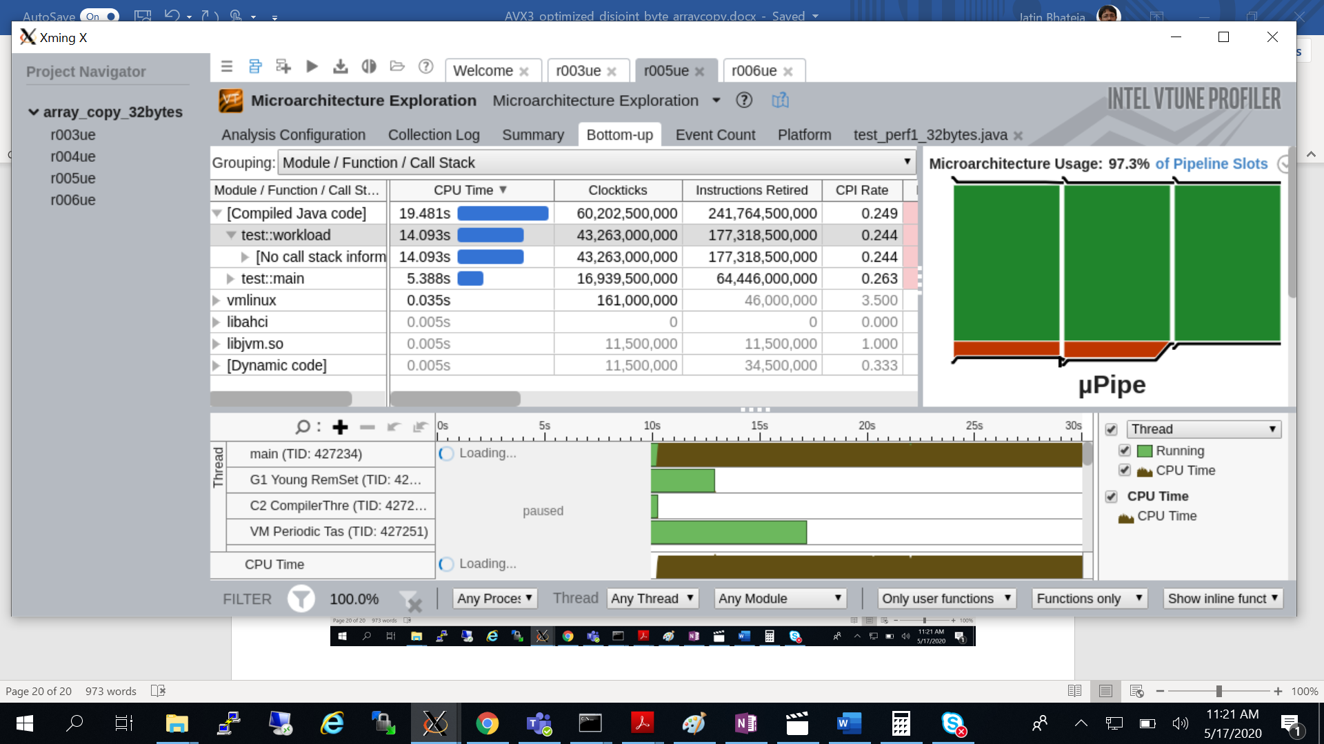

STUB: workload() {

System.arraycopy(src, cnt, dst, cnt, cnt)

Return dst[cnt];

}

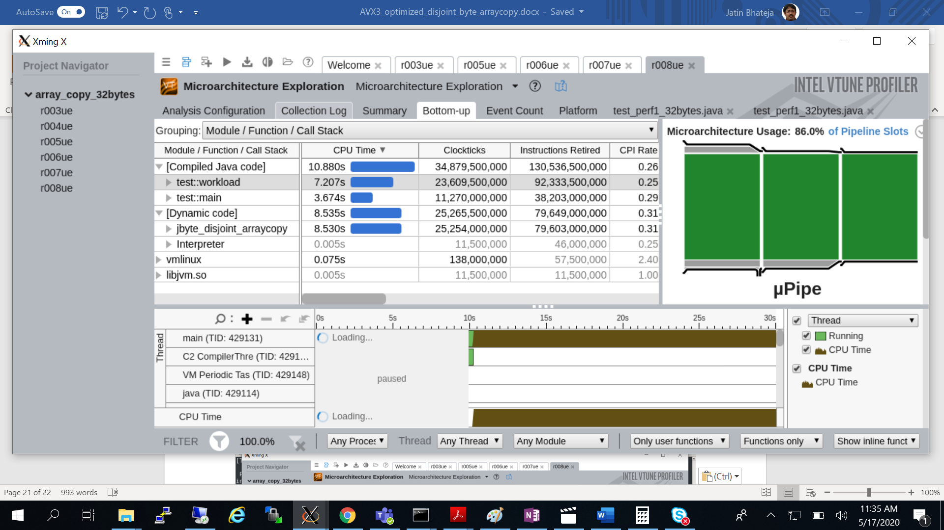

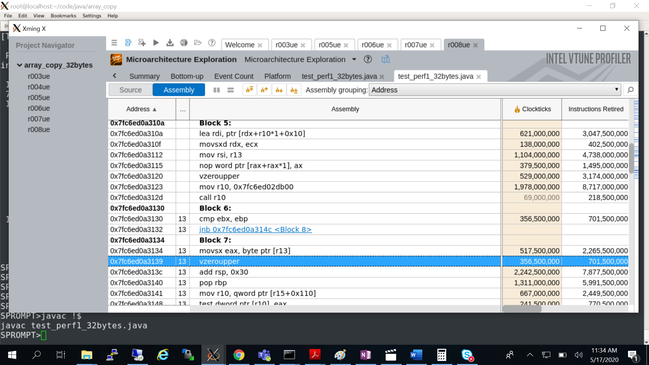

STUB: workload() {

System.arraycopy(src, cnt, dst, cnt, cnt)

Return dst[0];

}

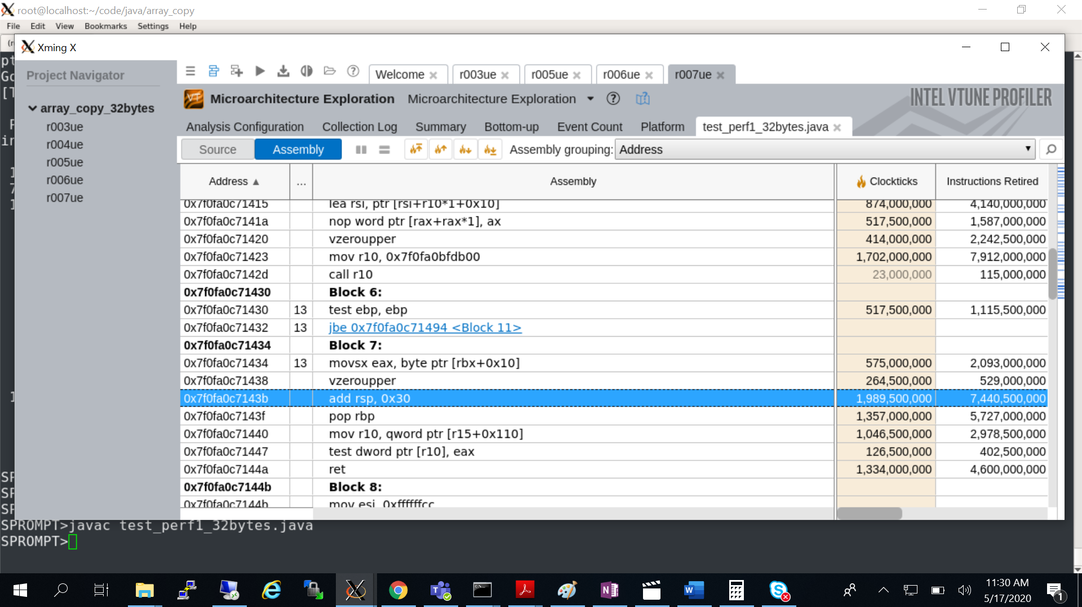

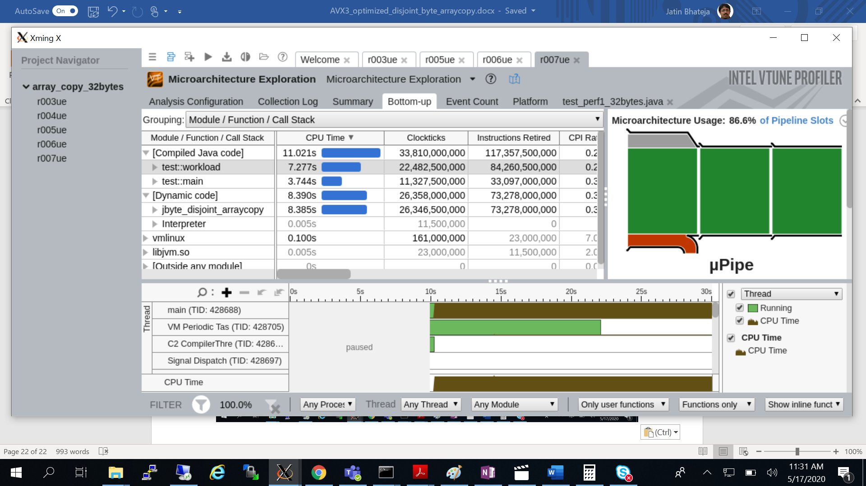

Array copy acceleration using AVX3 masked instructions:

Compile Side:

If (copyLength < ArrayCopyPartialInlineSize) {

Mask_Gen;

Vector_Copy;

} else {

Call AVX3_Opt_Stub

}

New Runtime Flags:

* ArrayCopyPartialInlineSize = 32 (default) / 64 bytes.

Stub Side:

Tail:

// All operation at highest frequency (LVL0).

Generate_Special_Cases_32-256bytes_using_MV32();

Goto Exit

if (CopyLength < AVX3Threshold) {

// All operation at highest frequency (LVL0).

Align_Dst_Address_32byte ();

Main_copy_loop_256bytes_32byte_granularity ();

Jmp Tail;

} else {

// Lower frequency (LVL1) operations.

Align_Dst_Address_64byte ();

Main_copy_loop_256bytes_64byte_granularity ();

Tail_Handling_0-256bytes_using_MV64 ();

}

Exit:

Return_From_Stub

**SPECjbb2015 perf runs AVX3:**

Original Perf numbers:

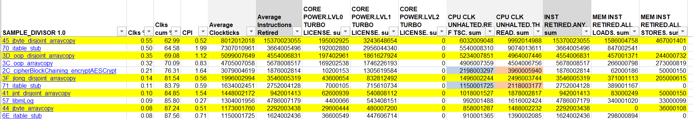

With Stub Optimization Perf numbers:

